# 

Project Management Plan

Project Charter…………………………………….……..3

Project Scope…………………………………………….10

Stakeholder Engagement Plan…………………...…….16

Communication Management Plan…………………….27

Project Name: AI Tester

Company Name: Artificial Systems

Sponsor: Amazon

Effective Date: September 23, 2020

Document Authors: Garrett Herington

Camryn Rogers

Md Rakeen Murtaza

Michael Efughu

To Kim Bao Pham

Table of Contents

# 

**Project Charter** **3**

Project overview 3

Project Definition 3

Project scope overview 4

Project stakeholders (Pull from stakeholders analysis) 6

Project Milestones 8

Project Budget 9

Assumptions and considerations and risks 9

**Project Scope (SOW)** **10**

Introduction 10

Approach 11

Roles and Responsibilities 11

Work Breakdown Structure (WBS) 14

Updated Work Breakdown Structure (WBS) 15

**Stakeholder Engagement Plan** **16**

Introduction 16

Classification based on analysis and stakeholder’s engagement 16

Projects power/dynamism matrix 17

Updated stakeholder list 19

Benefits 26

**Risk Management Plan** **26**

**Change Management Plan** **26**

**Lessons Learned** **26**

**Communication Management Plan** **27**

# 

# Project Charter

## Project overview

Artificial Systems is a DevOps automation company, whose primary work involves the delivery of state-of-the-art testing tools, APIs and softwares that can perform a conglomeration of tests on web applications and mobile applications to identify security weaknesses and vulnerabilities as well as conduct performance scans and other metrics. Amazon.com Inc., on the other hand, is an American multinational technology company based in Seattle, Washington. Amazon focuses on e-commerce, cloud computing, digital streaming, and artificial intelligence. Artificial Systems’ current project with Amazon is to deliver the most technologically advanced AI testing and automation tool that will streamline DevOps and Software Engineering processes on Amazon’s eCommerce site.

## Project Definition

Artificial Systems will design an ‘AI Tester’ that will perform a conglomeration of tests on Amazon’s eCommerce web applications and mobile applications to identify security weaknesses and vulnerabilities on core areas such as web checkouts, payment systems etc. as well as conduct performance scans and other metrics for superior usability. This AI Tester will replace the need for conventional testing and maintenance. It will help maximize efficiency and productivity in the software testing process. It is a streamlined testing tool that will minimize time and cost to produce and maintain the websites and mobile applications, which reduces the workload on Amazon’s DevOps processes.

## Project scope overview

The scope of this project is to design a AI Testing product that can run a series of tests which will cover all the nooks and crannies of Amazon’s eCommerce sites and look for possible improvements.

The program will have an architectural combination of front-end and back-end attributes that will allow state-of-the-art software testing. The front-end of the program will consist of a Program Dashboard, a Runtime Dashboard, and a Post-Runtime Dashboard. Here is a quick overview of the front-end components:

Program Dashboard

* Scan all links, test destinations for unresponsive or erroneous webpages.
* Test web pages for UI responsiveness.

Runtime Dashboard

* Tests the UI workflow of the website/app to check if webpage links are synchronized with button clicks
* Tests whether SEO strategies are implemented correctly, including title tags, meta descriptions, URL structure and image alt tags

Post-runtime Dashboard

* Perform boundary value analysis on front-end forms.
* Tests website compatibility with multiple browsers and operating systems, then identifies UI discrepancies between them

The back-end functionalities of our program is where the real magic happens, as it performs a series of security and performance analysis of the websites. The backend components would include:

Pose as artificial user, and test back-end workflow

* + Fill in forms, or other areas of user-input and test to ensure proper data flow
  + Tests if social media integration is aligned with website architecture and workflow
  + Tests the workflow of the website/app consisting of the:
    - Login and Signup options
    - Search functionality
    - Product review posting feature
    - Sorting feature
    - Applying filters for choosing the desired product(s)
    - Add/remove functionality in the shopping cart
    - Check out process
    - Order number and invoice generation
    - Payment gateway and payment processing

Ethical hacking system: Test data leak, security etc

* + Apply security threats on the system to test response and detection systems, like DDoS or Brute-force attacks.
  + Attempt to travel into administrative pages.
  + Attempt to collect and decode encrypted files.

Performance analysis system:

* + Increase load on each page to test performance response.
  + Performance testing that includes:
    - Webpage loading speed
    - Throughput
    - Data transfer rate
    - Efficiency
    - Uptime
    - Database performance
    - Website traffic load tolerance
    - Error messages

Payment security and testing for eCommerce:

* + Tests the payment gateway to ensure that it functions properly and provides security while doing transactions

Connectability:

* + Apply VPN to test server ping response, connectability.

Amazon’s expectation for project acceptance is successful completion of all the major components listed above with 1% of defect tolerance with low severity and no failures in core areas (such as successful checkout). The system should be easy to navigate and self-explanatory with the help tab option available. The project should achieve its overall goal and be finished on time and within budget.

The duration of the project is 9 months, expected to begin with the design phase from December 1st 2020 and deploy a completely tested system by September 2nd 2021. Artificial Systems’ AI Tester portal is scheduled to be displayed on Amazon SWE offices on September 10th.

## Project stakeholders (Pull from stakeholders analysis)

The key project stakeholders are as follows:

Project Sponsor: Craig Rogers

Project Manager: Felisa Ramen

Design Team Lead: Jim Qu

Architecture Team Lead: Tate Lee

Testing Team Lead: Lila Loney

Deployment Team Lead: Walter White

Front End Development Team Lead: Bill Boney

Back End Development Team Lead: Jill Joney

Database Team Lead: Buck Horseman

Security Team Lead: Ren Chen

Technical Director: Jesse Pinkman

Business Analyst: Joe James

IT Manager: Huck Finn

The other stakeholders that belong to the project team are:

Requirements Team (4): Tom Lee

Ash Burn

Joe Lee

Sky Rut

Design Team (1): Hoster Lo

Architecture Team (2): Berney Day

Fanny May

Testing Team (4): Abe Line

Bell Ann

Tre Marts

Lin Day

Deployment Team (4): Win Not

Tot Lot

Bot Cot

Foot Fung

Database Team (2): Bill Nye

Char No

Front End Team (4): Windy Li

Bendi Chi

Fendi Ti

Rachel Fi

Back End Team (4): To Tom

Bo Bom

Lo Lom

So Som

Security Team (4): Long Len

Ben Ten

Den Hen

Len Yen

These project stakeholders are a part of the project and will be involved throughout the project development life cycle.

## Project Milestones

Projects milestone with all the major activities throughout the development are listed below:

|  |  |  |  |  |  |
| --- | --- | --- | --- | --- | --- |
| **Milestone** | **Status** | **% Done** | **Start Date** | **End Date** | **Comments** |
| Project Start | C | 100 | 10/15/20 | 10/15/20 | Completed on time |
| Create Governance Plan | C | 100 | 11/9/20 | 11/13/20 | Completed early |
| Requirements phase | C | 100 | 11/16/20 | 2/10/21 | Completed on time |
| Design phase | C | 100 | 2/11/21 | 6/21/21 | Completed on time |
| Coding phase | G | 13 | 6/3/21 | 12/30/22 | First-iteration of backend |
| Testing phase | G | 0 | 1/2/23 | 5/1/23 |  |
| Deployment phase | G | 0 | 5/2/23 | 8/3/23 |  |

## Project Budget

The total budget of the project is $2,369,400. It includes the employee salaries for 731 days. It has been agreed that we will develop the product to function with Amazon AWS, and will be granted temporary AWS resources for the duration of the project. All figures were calculated in USD.

## Assumptions and considerations and risks

Assumptions and considerations for the AI Tester for Amazon are:

Amazon's development team will have access to the final product and will be responsible for executing the solution we give them. Amazon developers will give inputs on

determining the UI, and the most convenient way to visualize information from the set of features that are being developed. Amazon will also provide documentation on their technical infrastructure to facilitate integration with out platform.The Amazon project representative is available to contact when details are required and is expected to be involved in the project development process.

# Project Scope (SOW)

## Introduction

The purpose of this Scope Management Plan for the AI Tester of Amazon eCommerce websites is to ensure the project is composed of all the work required to successfully complete the project. This document includes the information on all the tasks necessary to achieve the objective of the project and excludes that is not essential.

This plan document shares light on the approach we are using for managing the scope of the project, defining the roles and responsibilities for the project, and how we are going to validate & control the scope of the project.

The scope management plan document of the AI Tester program includes information on the following:

* + Collection of requirements from Amazon eCommerce

Requirements are gathered based on the project charter, business documents, and stakeholder registry. Collectively we have identified requirements, discussed and clarified the details for each requirement to define the next step of scope definition for the project

* + Scope definition of AI Tester

This is an important part of the document as it includes the detailed description of the project and product. The scope definition confines the project requirement from all the requirement collection and gives details on the deliverable associated for the project completion.

* + Work Breakdown Structure (WBS) of the AI Tester

Based on the scope and functional specifications, a work break structure is created. WBS is a hierarchical process of breaking the project deliverables into smaller and more manageable components to achieve the project's objective.

* + Scope Validation

This section includes the information on the process of verifying and formalizing the deliverables against the scope of the project for their formal acceptance.

* + Scope Control

This section describes the process of monitoring and controlling the project scope. This also includes managing the changes into the baseline scope.

## Approach

Project sponsor is responsible for defining the scope of the project with the help of other team members, manages all the changes related to scope and ultimately approves the deliverables and funds for scope changes.

Scope management plan focuses on the following processes:

* + Define scope
  + Work breakdown structure
  + Scope statement
  + Scope validation
  + Scope control

These processes interact with each other and with the processes in the other management plans defined in the Project Management Plan. When implemented properly, the scope management processes will help effectively manage the elements of time, schedule, and cost to support a project.

## Roles and Responsibilities

|  |  |
| --- | --- |
| **Role** | **Responsibilities** |
| Project Sponsor | 1. Provide fund to the project and approve budget 2. Define and approve changes to the scope 3. Communicate the project goals 4. Approve project charter and other subsequent documents. 5. Perform all the business decision making of the project and handle issues raised by the project manager. |
| Project Manager | 1. Collaborate with teams and create project management plans 2. Manage deliverables according to plans. 3. Lead and manage the project 4. Resource allocation in the project 5. Determine and approve project schedules and milestones. 6. Regulate updates and status reports to the project superiors 7. Plan team meetings and monitor projects progress. |
| Project Team Leaders | 1. Participate in project prime document creation like project charter, scope, requirement, plan documents etc. 2. Lead the team meetings 3. Ensure all the projects progress and document updates accordingly. 4. Take follow-ups from other teams on issues blocking the processes. 5. Ensure all teams complete the process as per the responsibilities allotted. |
| Technical Director | 1. Ensures the successful development of product as per the functionality requirements defined by Amazon 2. Manage the technical risks and mitigation activities. 3. Make key software design and implementation decisions with development and test teams. |
| Business Analyst | 1. Assist in gathering requirements from Amazon’s sponsor or business units 2. Document technical and business requirements. 3. Verify project deliverables meet requirements. 4. Provide a status report to the clients. |

|  |  |
| --- | --- |
| IT Manager | 1. Ensure appropriate environment setup and resource availability for the project to continue. 2. Software maintenance responsibility 3. Responsible for security of the product, so that each tool is customized for client DevOps and cannot be used/accessed by third-party. |
| Front End, Back End, Database, Design, and Architecture Engineers | 1. Contribute in overall project and documentation 2. Product development as per the requirements 3. Write development code and perform unit testing 4. Develop and integrate modules of the project. |
| Test Engineers | 1. Contribute in overall project and documentation 2. Validate product development as per the requirements 3. Perform integration, system and user acceptance testing 4. Generate defect reports and ensure quality of the product is matching the requirement by verifying defect fixing. |
| Security Engineers | 1. Contribute in overall project and documentation 2. Ensure security of AI Testing Algorithm 3. Ensure that data is not vulnerable and the system is not open to attack 4. Ensure the safety of the user’s data |
| Requirements  Engineers | 1. Work with Business Analyst in gathering requirements from Amazon’s sponsor or business units 2. Document technical requirements. 3. Verify project deliverables meet requirements. |
| Deployment  Engineers | 1. Contribute in overall project and documentation 2. Ensure the deployment of the software is timely and in the proper manner 3. Verify project deliverables meet requirements. |

*Table 1: Roles and responsibilities*

## Work Breakdown Structure (WBS)

Project scope is further decomposed with help of work breakdown structure (WBS). This WBS is of the process that is to be followed in the AI Tester system development. Multiple process activities will be followed from project initiation to project closure which are listed in hierarchical structure below.

The WBS explained in this document consists of 8 iterations, producing a workable product at the end of each iteration. Each iteration will build on the previous iterations until the final product is produced. The first iteration will consist of basic functionality and communication, confirming that the AI system is properly scraping a test system. It will also confirm proper data communication and documentation on the test system to the target database. The second iteration will be building a model of the data collection on the test system to properly train the AI tester. The third iteration will be expanding usable operating systems . The fourth iteration will focus on stress testing. The fifth iteration will handle security and dead links. The six iteration will apply the error handling and auto-correction system. The seventh iteration will focus on usability. The eighth iteration will be quality assurance.

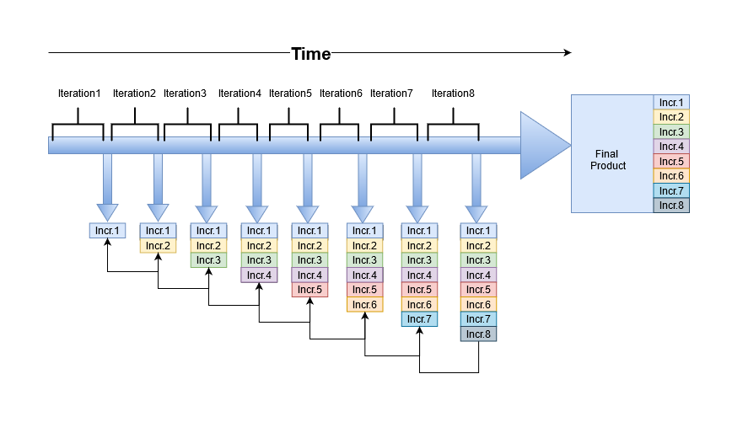

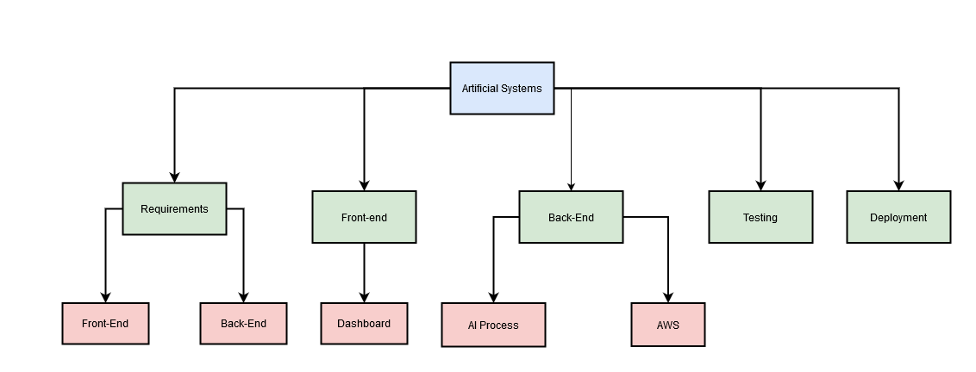

*Fig 1: Simple Work Structure and Iteration Workflow Diagram for Artificial Systems AI Software*

## Updated Work Breakdown Structure (WBS)

WBS of Artificial Systems describes the functional documents in 4 levels.

* + - Level 1 is the overall system level
    - Level 2 is functional processes of project development
    - Level 3 is major deliverables after every activity in project lifecycle
    - Level 4 is work packages of the parent activity

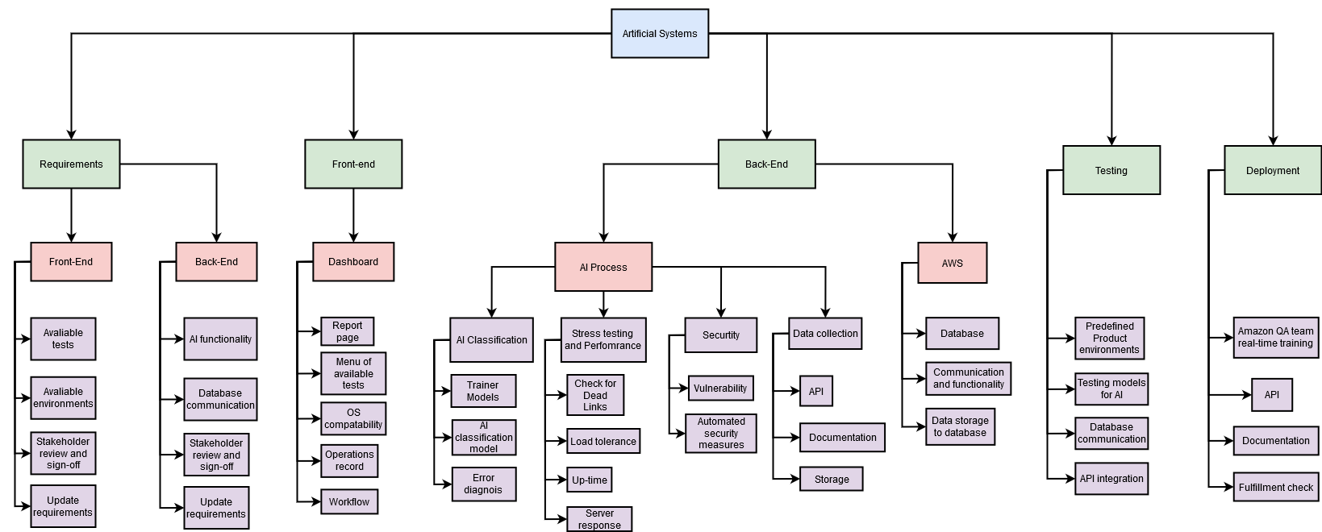

*Fig 2: Functional Work Breakdown Structure for Artificial Systems AI Software*

# Stakeholder Engagement Plan

## Introduction

Based on the needs of the project and the expectations of stakeholders, the stakeholder engagement plan is created. It aims to identify the strategies and actions required to promote productive involvement of stakeholders in decision making and execution. It includes a

## Classification based on analysis and stakeholder’s engagement

Key stakeholders of the project are prioritized and classified using two main factors of power and interest they have in the project.

Power is the authority of the employee. Higher the authority higher is the access to different documents and processes. This makes the person with higher authority more important to get the required approvals.

Interest is the concern shown by the project participant. Interest can vary depending on how the project affects the participant considering the designation and power he/she is at.

Taking these two factors into consideration we are classifying the stakeholders in following categories:

* **High power, highly interested people (Manage Closely)**: Stakeholders with high power and high interest in the project must be involved for all the major management decisions throughout the project. Participants belonging to this category are the key stakeholders and have responsibilities of and they are the Project sponsor, Project manager, Technical director etc.
* **High power, less interested people (Keep Satisfied)**: Stakeholder with high power but comparatively less interest in the project can be involved in important technical decision making and give their inputs to the supporting project management actions. Participants belonging to this category can also be included in the key stakeholders and they are Project Tech Lead, Business Analyst etc.
* **Low power, highly interested people (Keep Informed)**: Low power and highly interested people can be IT manager, team leads etc. These participants are involved in the project life cycle throughout, but their major focus area is the development phase of the project. The interest here differs as they are not directly affected by the project success or failure but are held responsible for any functional issues that affect the project success. Due to that, these stakeholders should be informed about all the major changes in the project and they submit status reports of the project's progress.
* **Low power, less interested people (Monitor)**: These are the participants that have less authority in the project and are not directly affected by the project success or failures. But they are involved in the project development life cycle and play a major role of building the software. They are monitored by the higher authority or the key stakeholders for all the activities they follow. These participants can be the projects software engineers, test engineers, architects, quality analysts etc.

## Projects power/dynamism matrix

Power/dynamism matrix that we found after researching about it. The below figure describes the relation between power and dynamism and how that can be measured for any project.



*Fig3: Generic Power/ Dynamism matrix*

Based on the above matrix we calculated the power, dynamism relation for our project. It is as follows. The letters correspond with the stakeholder mapping below:



*Fig4: Power/ Interest matrix of Stakeholders of Automated Systems*

The above matrix identifies the stakeholders as per their power and interest. They are located into different quadrants varying the range from high to low. This mapping shows the stakeholders importance and engagement in the project.

## Updated stakeholder list

When the project is in its infancy, our customers will also join the discussion of the project. Customers are one of the important stakeholders as they have high power and high interest in the complete project. Their needs should always be in the first place, and our designs and products should be based on their needs.

|  |  |  |  |  |  |  |  |
| --- | --- | --- | --- | --- | --- | --- | --- |
| **Lvl** | **ID** | **Stake-**  **holder** | **Title** | **Responsibilities** | **Reports To** | **Commun-**  **ications Modes** | **Email** |
| 1 | A | Felisa Ramen | Project Manager | Responsible for managing the activities of the project. He must ensure that the project goals are aligned with the organization’s goals and communicate with all the stakeholders to meet their needs and requirements and ensure the success of the project. | Artificial Systems Senior Management | In-person, email, phone | framen@asystems.com |
| 1 | B | Craig Rogers | Project Sponsor | Responsible for providing funding to the project and approving budget, defining and approving changes to the scope, communicating the project goals, approving project charter and other subsequent documents. Also for performing all the business decision making of the project and handling issues raised by the project manager. | Artificial Systems Senior Management | In-person, email, phone | crogers@asystems.com |
| 1 | C | Joe James | Business Analyst | Responsible for assisting in gathering requirements from Amazon, documenting technical and business requirements,  verifying project deliverables meet requirements, and providing status reports to the client. | Project Manager | In-person, email, phone | jjames@asystems.com |
| 1 | D | Johnny Lee | Design Lead | Responsible for leading the design of the testing algorithm and it’s user interface to comply with the requirements and ensuring that it meets the requirements. | Project Manager | In-person, email, phone | jlee@asystems.com |
| 1 | E | Tate Lee | Architecture Lead | Responsible for leading the team that designs the architecture of the testing AI to ensure that it creates the best result that fulfills the requirements. | Project Manager | In-person, email, phone | tlee@asystems.com |
| 1 | F | Lila Loney | Testing Lead | Responsible for leading the testing of the different parts of Artificial Systems to ensure that they work in accordance to the requirements in terms of quality and functionality. | Project Manager | In-person, email, phone | lloney@asystems.com |
| 1 | G | Walter White | Deployment Lead | Responsible for leading the release of Artificial Systems’ AI Testing software, making sure it is available to Amazon. | Project Manager | In-person, email, phone | wwhite@asystems.com |
| 1 | H | Bill Boney | Back End Lead | Responsible for leading the development of the back end of Artificial Systems in accordance to the design created, including the AI algorithm. | Project Manager | In-person, email, phone | bboney@asystems.com |
| 1 | I | Jill Joney | Front End Lead | Responsible for leading the development of the front end of Artificial Systems and its interface in accordance to the design created. | Project Manager | In-person, email, phone | jjoney@asystems.com |
| 1 | J | Buck Horseman | Database Team Lead | Responsible for leading the creation and management of all of the databases that are used in the project. | Project Manager | In-person, email, phone | bhorseman@asystems.com |
| 1 | K | Ren Chen | Security Lead | Responsible for leading the security team in ensuring the security of the software so that user’s data is not at risk. Responsible for leading the security of users using AI Testing software as well as the data security of Artificial Systems’ data. | Project Manager | In-person, email, phone | [rchen@asystems.com](mailto:rchen@asystems.com) |
| 1 | L | Huck Finn | IT Manager | Responsible for ensuring the security of Artificial Systems, ensuring appropriate environment setup and resource availability for the project to continue, and  software and hardware maintenance. | Project Manager | In-person, email, phone | hfinn@asystems.com |
| 1 | M | Tom Lee  Ash Burn  Joe Lee  Sky Rut | Requirements Team (4) | Responsible for aiding the business analyst in gathering requirements. Responsible for defining, documenting, and maintaining requirements in the design process. | Business Analyst | Email | [tlee@asyystems.com](mailto:tlee@asyystems.com)  [aburn@asystems.com](mailto:aburn@asystems.com)  [jlee@asystems.com](mailto:jlee@asystems.com)  srut@asystems.com |
| 1 | N | Hoster Lo | Design Team (1) | Responsible for designing the user interface of Artificial Systems to comply with the requirements. | Designer Lead | Email | hlo@asystems.com |
| 1 | O | Berney Day  Fanny May | Architecture Team | Responsible for designing the architecture of the testing AI to ensure that it creates the best result that fulfills the requirements. | Architecture Team Lead | Email | [bday@asystems.com](mailto:bday@asystems.com)  fmay@asystems.com |
| 1 | P | Abe Line  Bell Ann  Tre Marts  Lin Day | Testing Team (4) | Responsible for testing the different parts of Artificial Systems to ensure that they work in accordance to the requirements in terms of quality and functionality. | Testing Lead | Email | [aline@asystems.com](mailto:aline@asystems.com)  [bann@asystems.com](mailto:bann@asystems.com)  [tmarts@asystems.com](mailto:tmarts@asystems.com)  lday@asystems.com |
| 1 | Q | Win Not  Tot Lot  Bot Cot  Foot Fung | Deployment Team (4) | Responsible for the release of Artificial Systems’ AI Testing software, making sure it is available to Amazon. | Deployment Team Lead | Email | [wnot@asystems.com](mailto:wnot@asystems.com)  [tlot@asystems.com](mailto:tlot@asystems.com)  [bcot@asystems.com](mailto:bcot@asystems.com)  ffung@asystems.com |
| 1 | R | Bill Nye  Char No | Database Team (2) | Responsible for the creation and management of all of the databases that are used in the project. | Database Team Lead | Email | [bnye@asystems.com](mailto:bnye@asystems.com)  cno@asystems.com |
| 1 | S | Windy Li  Bendi Chi  Fendi Ti  Rachel Fi | Front End Team (4) | Responsible for developing the front end of Artificial Systems and its interface in accordance to the design created. Also assists back end development when needed. | Front End Team Lead | Email | [wli@asystems.com](mailto:wli@asystems.com)  [bchi@asystems.com](mailto:bchi@asystems.com)  [fti@asystems.com](mailto:fti@asystems.com)  rfi@asystems.com |
| 1 | T | To Tom  Bo Bom  Lo Lom  So Som | Back End Team (4) | Responsible for developing the back end of Artificial Systems in accordance to the design. | Back End Team Lead | Email | [ttom@asystems.com](mailto:ttom@asystems.com)  [bbom@asystems.com](mailto:bbom@asystems.com)  [llom@asystems.com](mailto:llom@asystems.com)  ssom@asystems.com |
| 1 | U | Long Len  Ben Ten  Den Hen  Len Yen | Security Team (4) | Responsible for ensuring the security of the software so that user data is not at risk. Responsible for the security of users using AI Testing software as well as the data security of Artificial Systems’ data. | Security Lead | Email | [llen@asystems.com](mailto:llen@asystems.com)  [dhen@asystems.com](mailto:dhen@asystems.com)  lyen@asystems.com |
| 2 | V | Jesse Pinkman | Technical Director | Responsible for providing computing, software, and communications support to the main development team. | Artificial Systems Senior Management | Email, in-person | jpinkman@asystems.com |
| 2 | W | Jimmy John | President of Artificial Systems | Responsible for ensuring that all projects taken on by Artificial Systems, including the project contracted with Amazon, is in accordance with Artificial Systems’ goals and principles. | CEO of Artificial Systems | In-person meeting, email | jjohn@asystems.com |
| 2 | X | Yemen Simons | Artificial Systems Senior Management | Responsible for managing the different projects in which the organization is involved in. Project Manager of testing protocol software reports to them. | President of Artificial Systems | In-person meeting, email | ysimons@asystems.com |
| 2 | Y | Germaine Daniels | Amazon App Quality Assurance Team Lead | Responsible for the oversight of quality of Amazon’s mobile application. Requests the utilization of Artificial System’s software to help Amazon’s testing team achieve the maximum possible quality of Amazon’s mobile application. | Amazon Senior Management | In-person meeting, email | gdaniels@amazon.com |
| 2 | Z | Bob Builder | Amazon Website Quality AssuranceTeam Lead | Responsible for the oversight of quality of Amazon’s website. Requests the utilization of Artificial System’s software to help Amazon’s testing team achieve the maximum possible quality of Amazon’s website. | Amazon Senior Management | In-person meeting, email | bbuilder@amazon.com |
| 2 | Aa | Doe Jon | Amazon End Users | Responsible for providing feedback about Amazon’s website and mobile app. Report to Quality Assurance Teams about user experience and bugs that they encounter. | Amazon Quality Assurance Teams | In-person | djon@gmail.com |
| 3 | Ab | Maria Lopez | Amazon Website Testing Team Lead | Responsible for utilizing Artificial System’s software in order to expedite testing of Amazon’s website. | Amazon Senior Management | In-person | mlopez@amazon.com |
| 3 | Ac | Christina Ronaldo | Amazon App Testing Team Lead | Responsible for utilizing Artificial System’s software in order to expedite testing of Amazon’s mobile application. | Amazon Senior Management | In-person | cronaldo@amazon.com |
| 4 | Ad | Limma Bene | President of Amazon | Responsible for ensuring that all projects taken on by Amazon, including the Artificial System’s testing protocol, are in accordance with Amazon's goals and principles. | CEO of Amazon | In-person meeting, email | lbene@amazon.com |
| 4 | Ae | Dante Christopherson | Amazon Senior Management | Responsible for overseeing all projects and offices and their activities, ensures the overall quality of Amazon services including their website and mobile application. | President of Amazon | In-person meeting, email | dchristopherson@amazon.com |



*Fig5: Graphic Diagram of Stakeholder Mapping*

The stakeholders from Artificial Systems are in the Power/Interest matrix in Figure 2.

These are the included stakeholders:

|  |  |
| --- | --- |
| Name Position | |
| Jimmy John | President of Artificial Systems |
| Yemen Simons | Artificial Systems Senior Management |
| Felisa Ramen | Project Manager |
| Craig Rogers | Project Sponsor |
| Joe James | Business Analyst |
| Johnny Lee | Design Lead |
| Tate Lee | Architecture Lead |
| Lila Loney | Testing Lead |
| Walter White | Deployment Lead |
| Jesse Pinkman | Technical Director |
| Bill Boney | Front End Lead |
| Jill Joney | Back End Lead |
| Buck Horseman | Database Lead |
| Ren Chen | Security Lead |
| Huck Finn | IT Manager |
| Tom Lee  Ash Burn  Joe Lee  Sky Rut | Requirements Team (4) |
| Hoster Lo | Design Team (1) |
| Berney Day  Fanny May | Architecture Team (2) |
| Abe Line  Bell Ann  Tre Marts  Lin Day | Testing Team (4) |
| Win Not  Tot Lot  Bot Cot  Foot Fung | Deployment Team (4) |
| Bill Nye  Char No | Database Team (2) |
| Windy Li  Bendi Chi  Fendi Ti  Rachel Fi | Front End Team (4) |
| To Tom  Bo Bom  Lo Lom  So Som | Back End Team (4) |
| Long Len  Ben Ten  Den Hen  Len Yen | Security Team (4) |

*Fig6: included stakeholders*

New stakeholders:

|  |  |  |
| --- | --- | --- |
| Name Position Department | | |
| Limma Bene | Amazon President | Head of the Executive Department |
| Dante Christopherson | Amazon Senior Management | Executive Department |
| Bob  Builder | Amazon Website Quality Assurance Lead | Quality Assurance Department |
| Germaine Daniels | Amazon App Quality Assurance Lead | Quality Assurance Department |
| Maria  Lopez | Amazon Website Testing Team Lead | Testing Department |
| Christina  Ronaldo | Amazon App Testing Team Lead | Testing Department |
| Doe Jon | Amazon End User | User |

*Fig7: customer list*

**New Projects power/dynamism matrix:**



*Fig8: New Power/ Interest matrix of Stakeholders of Artificial Systems’ AI Testing Software*

## Benefits

Stakeholder analysis helps with the identification of:

* + Identify project participants that play a key role in the project management process
  + Avoid the potential risks and misunderstandings of communication in the project
  + Find the way to positively influence other stakeholders
  + Manage the negative stakeholders as well as their adverse effects on the project

# 

# 

# 

# 

# 

# 

# 

# 

# 

# Risk Management Plan

**Introduction**

# 

The following flowchart documents the overall risk management process that, once implemented, will help Artificial Systems to proactively foresee risks, estimate impacts, and define responses to risks.

The flowchart shows that the process begins with the identification of each risk, a validity check, which, if valid, pushes the risk to the evaluation process, from where control measures are implemented.

The table that follows explains each of the elements that are involved in the chart, including the color schemes which appropriately shows the priorities of each associated risk.

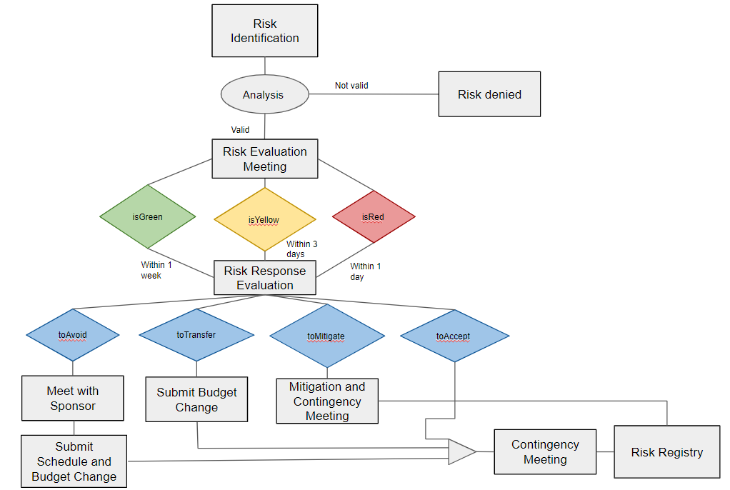

**Reference Table**

|  |  |
| --- | --- |
| Step | Details |
| Risk Identification | Analyze the project to identify sources of obvious risk  Risks can be submitted by team leads via email |
| Analysis | PM decides if the risk is worth looking more into based off of an initial review |
| Risk Evaluation Meeting | Project manager meets with team leads of teams who the risk will affect and gets counsel on the potential severity of the risk, the likelihood of it occurring, and the controllability of the risk. Together they use this information to decide if a risk is red (high risk), yellow (medium risk), or green (low risk). |
| IsRed | This risk is a priority and evaluated with urgency. |
| IsYellow | This risk is a mid level priority and evaluated after all red risks. |
| IsGreen | This risk is of the lowest priority and evaluated after yellow and red risks. |
| Risk Response Evaluation | The PM uses the information they gathered from the team leads to decide how they will respond: mitigate, avoid, transfer or accept |
| toMitigate | The PM has decided to mitigate the risk and will now schedule a meeting with affected team leads to decide how they will mitigate the risk |
| Mitigation and Contingency Meeting | The PM meets with the affected team leads and they decide on how to mitigate the risk. After deciding how to mitigate they also come up with a contingency plan as well as the triggers for that plan and who is responsible. |
| toAvoid | The PM has decided to avoid the risk. The PM must now evaluate the project plan to eliminate the risk or condition. |
| Meet with Sponsor | The PM has to meet with the project sponsor to alter the project plan to eliminate the risk, they also discuss the changes to the schedule and budget that must be made. |
| Submit Schedule and Budget change | The PM now submits a change to alter the schedule and budget to account for the change in the project plan. |
| toTransfer | The PM has decided to transfer risk and must now evaluate/change the budget to transfer the risk to a contracted party or purchase insurance. |
| Submit Budget Change | The PM submits a change to the budget to allocate funds for transferring risk. |
| toAccept | The PM has decided to accept the risk and now must develop a contingency plan for the risk. |
| Contingency Meeting | The PM meets with affected team leads to create contingency plans for the risk. They also decide on triggers for the contingency plans. The PM documents this information to be added to the Risk Registry. |
| Risk Registry | PM documents the risk in the risk registry. It includes information about each risk (i.e. nature of the risk, reference and owner, mitigation measures, contingency plans and triggers). Organize and prioritize risks by color. |

# Change Management Plan

# Lessons Learned

# 

# 

# 

# 

# 

# Communication Management Plan

|  |  |  |  |  |  |
| --- | --- | --- | --- | --- | --- |
| **What Information are we Providing?** | **How often will we provide?** | **Who is the audience?** | **How will we deliver the information?** | **Who will send the information?** | **Priority** |
| **Status Report – Project Level** | Weekly (Fridays by 5pm) | Project team, testers, department leads and engineers, UI designers | As part of weekly status meeting and email | Project Manager | High |
| **Status Report – Project Level** | Weekly (Fridays by 4pm) | Amazon Senior level Managers | Email only | Project Manager | Medium |
| **Status Report – Program Level** | Monthly (Last working day of month by 4pm) | Project leads | As part of Monthly status meeting and email | Project Manager | High |

|  |  |  |  |  |  |
| --- | --- | --- | --- | --- | --- |
| **Milestone Report** | Quarterly, (by last working day of quarter by 4pm) | Project leads, Amazon Senior level Managers, Amazon Senior Management, Amazon President | Email only | Project manager | High |
| **Financial Report** | Monthly (by last working day of the month by 4pm) | Amazon Senior management, Amazon senior level managers | Email only | Project manager | High |
| **Risk Information** | Weekly (During internal risk meeting) | Project manager, project leads, team engineers/testers | Weekly meeting and email | Project manager | High |

|  |  |  |  |  |  |
| --- | --- | --- | --- | --- | --- |
| **Issue Information** | Bi-Monthly (by 15th and 30th (Feb29) of every month) | Engineers/testers/designers, project leads, project manager | Meeting and email | Project manager | Medium |
| **Quality Reports** | Bi-Monthly (by 15th and 30th (Feb29) of every month) | Engineers/testers/designers, project leads, project manager | Meeting and email | Project manager | Low |
| **Change Requests** | When a change request has been received | Engineers/testers/designers, project leads, project manager | Send out email of change request | Amazon Senior management or project manager | High |

|  |  |  |  |  |  |
| --- | --- | --- | --- | --- | --- |
| **Technical Challenges** | When there are technical challenges | Necessary team members, project leads, project manager | In-person meeting, documentation of meeting sent out to attendees via email | Project lead, or project manager | Low |
| **Deployment Challenges** | When there are deployment challenges | Necessary team members, project leads, project manager | In-person meeting, documentation of meeting sent out to attendees via email | Project lead, or project manager | Low |
| **Resource Challenges** | When there are resource challenges | Necessary team members, project leads, project manager | In-person meeting, documentation of meeting sent out to attendees via email | Project lead, or project manager | Low |